Hi XXXX,

Thanks for connecting back on LinkedIn, I did try to reach out on their messaging app but not sure how active you are on there.

I thought I would drop you a quick note as I am keen to setup a call to discuss the potential of becoming one of our ‘Best Practice Showcases’ for the next editions of Business Chief Asia and Construction Global.

We are running a series of feature articles based around 'Mission Critical Technology' and have been focusing on the following areas amongst others:  
﻿  
● Mission Critical Transformations & Data Centre Construction

● Large Scale Design and Project Management

● Major Infrastructure Projects

● Sustainability & Green Initiatives

● Technology and IoT Initiatives

I think you could potentially be a perfect fit to be featured in the March/April issue and I would welcome the opportunity to discuss further, below are the latest editions of the magazines as well as a couple of examples of our brochures that are custom built post magazine, just click the covers:

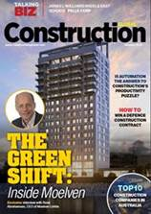 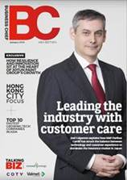 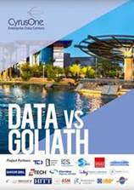 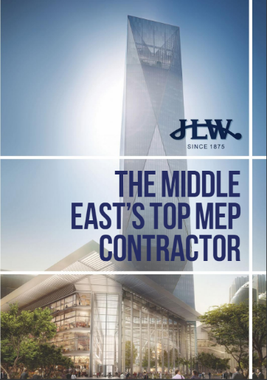 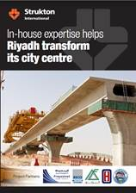 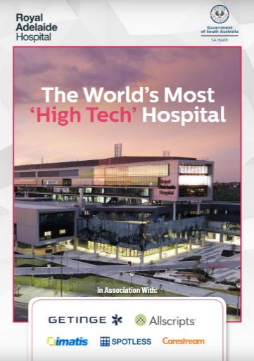

Let me know if this is of interest as I would like to try and set up a call in the next few days?

Thanks,